Proposed Lamprey Passage Improvement List for The Dalles and John Day
The Dalles East
- Grating – All 1” gap. New grating also 1” gap. Need to determine if ¾’ can be used effectively against wall where lamprey travel. New 1” gap grating on site to be installed in junction pool and east entrance. Reducing gap requires hydraulic analysis (velocity and volume), structural analysis and risk analysis in the event of zebra/quagga mussels. Prioritization for ¾ installation; 1) lower east and north ladder grating exposed during dewatering 2) Junction pool 3) East, West, South and North entrance equal priority value.
- Junction pool bulkhead stub walls – Used to prevent debris accumulation under bulkhead slot. Lamprey commonly found in this area during dewatering. Bulkheads not used here for at least 15 years. Picture below. Options; ramp or removal. 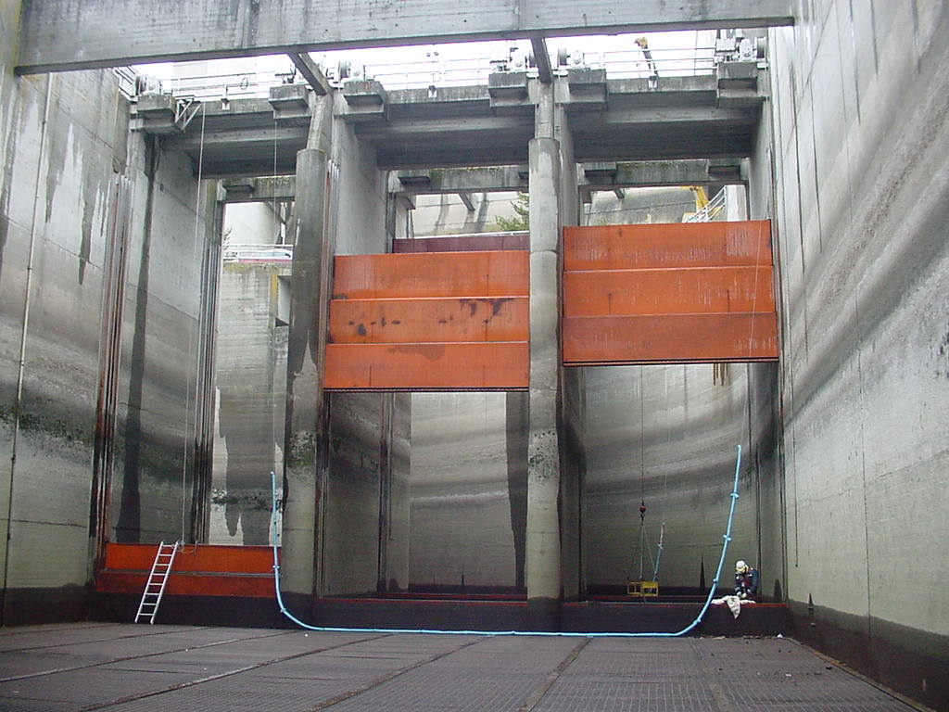
- Step up on first ladder weir – Needs a ramp. Will be a challenge due to grating. Could be chamfered. Picture below.
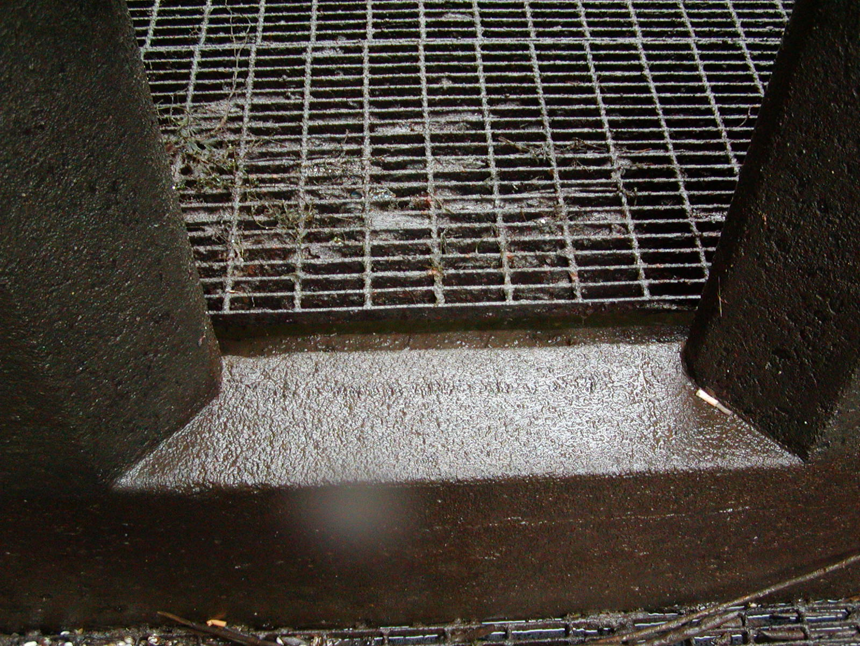
- Step up on 180 bend upstream weir – Needs ramp. Can be done by project during winter outage. No Picture.
- Weirs 154-147 – orifices raised various distance from floor. Options; new design or modify with ramp. Worn seals to be replaced to prevent lamprey entry into guide and potential crushing. Picture below.
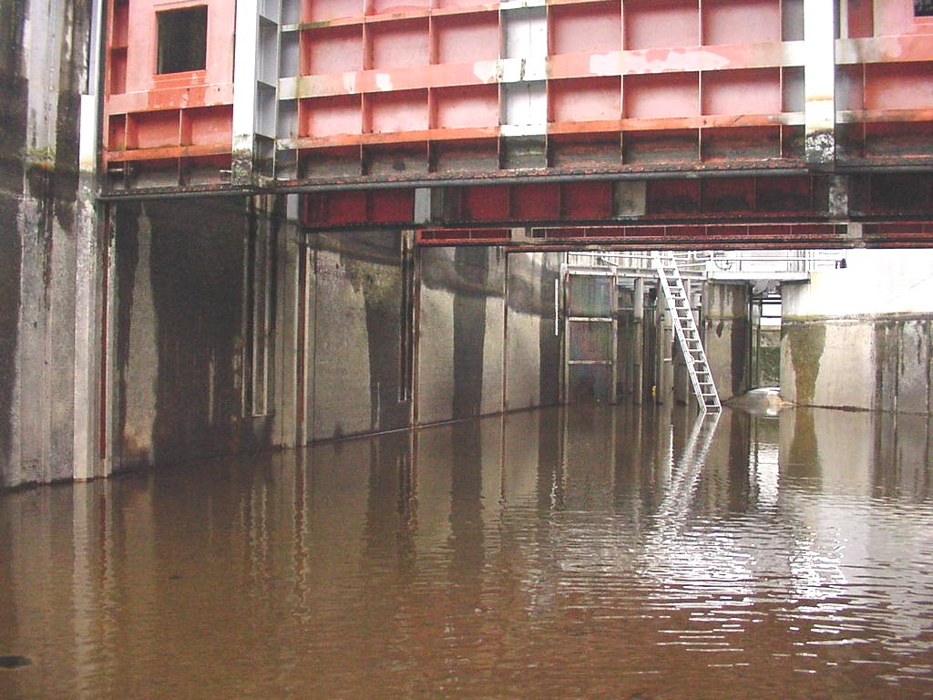
- Entrance and exit weir guides – Provide hiding place for lamprey. Potential crushing when weir makes adjustments. Lamprey observed pinched by lift beam extension. Option; install brush to deter lamprey entry. No picture.
- South entrance depression – 3’ floor depression immediately upstream of weirs. Option; ramp upstream edge of pool. Picture below.
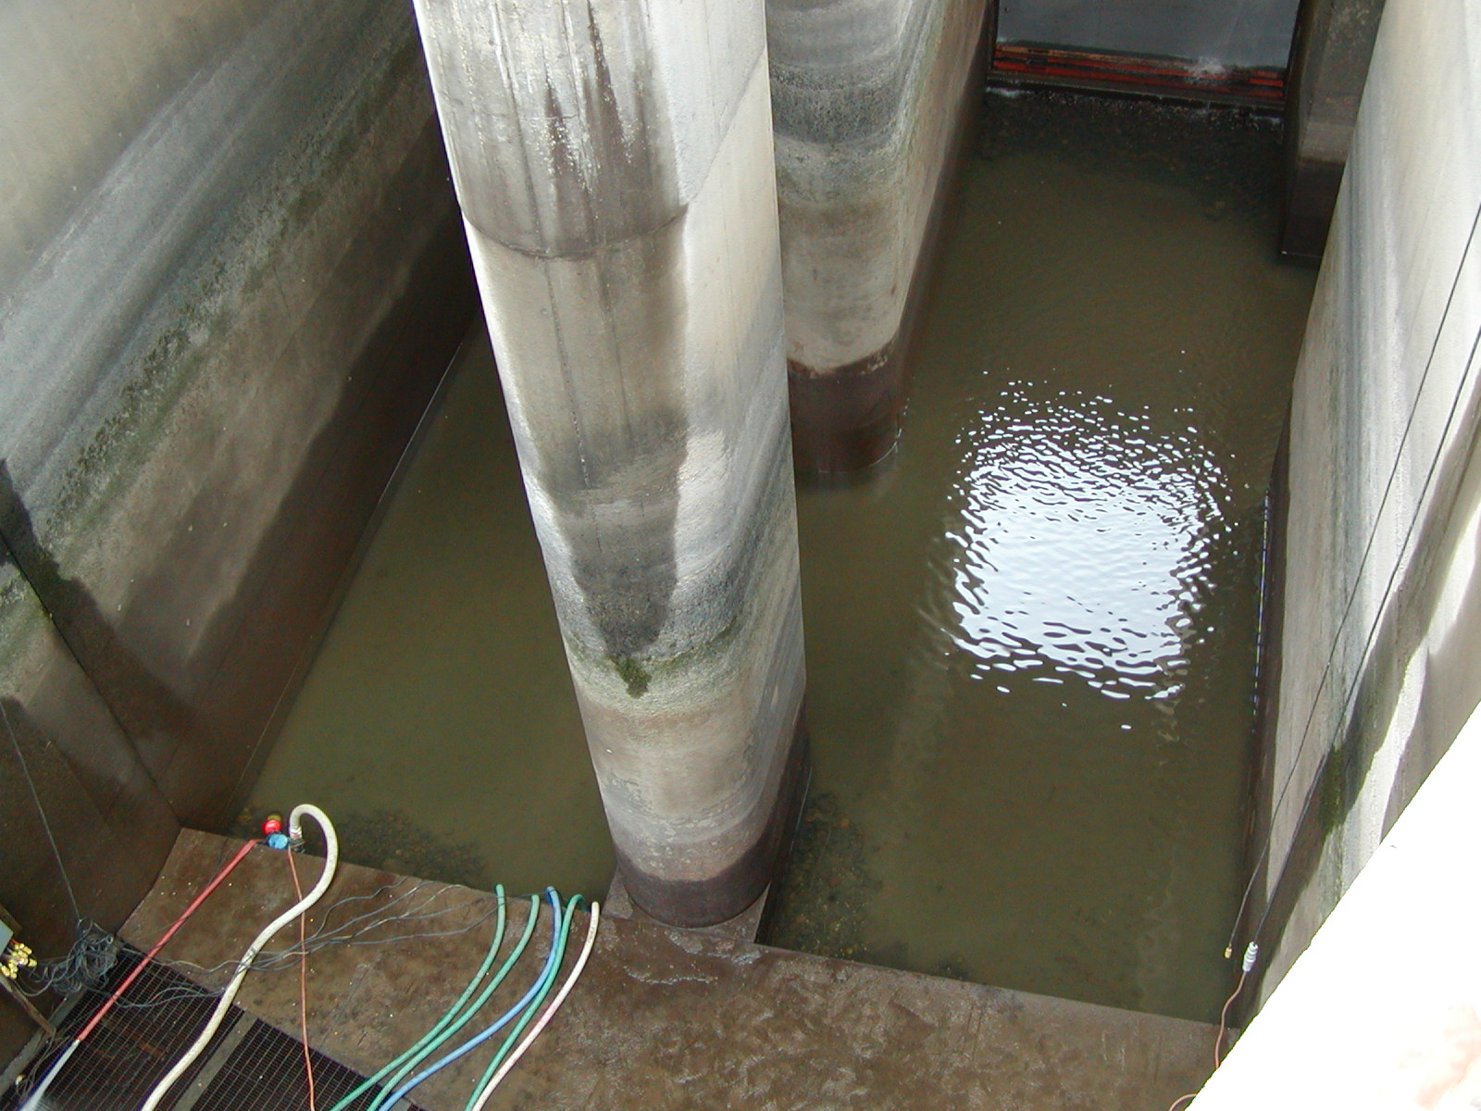
8) Collection channel depressions - Approx 20, 3’ deep floor depressions in channels. Even floor along sides may allow easier lamprey passage by these areas.

The Dalles North
- Grating – Same as above.
- Lower weir pools with rock pools – Floor raise up to 3’ to weir orifice. Option; ramp. Would require additional pumping for remove water from pool. Picture below.
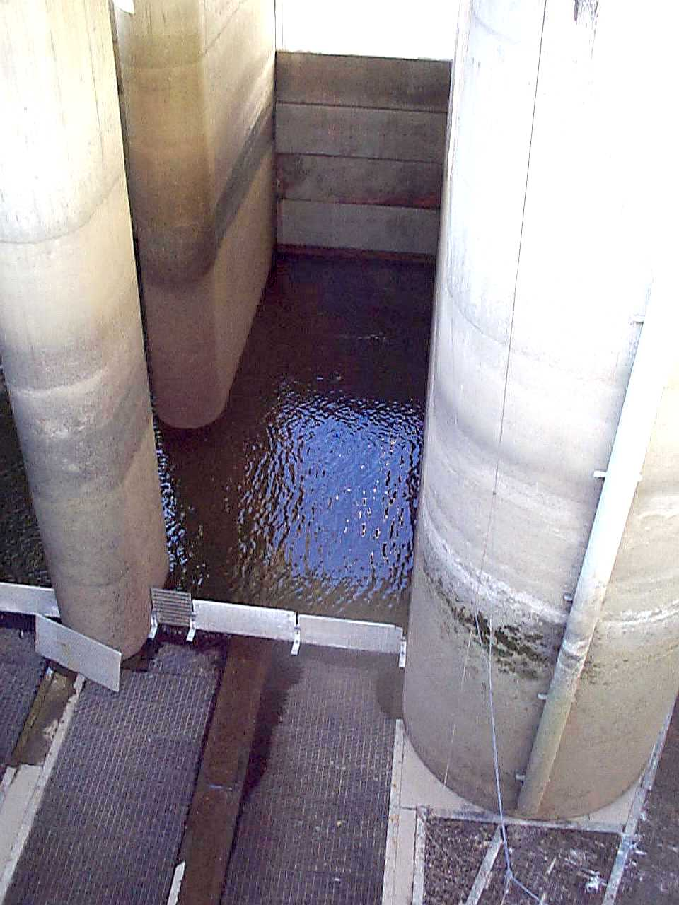
- North entrance depression – Same and south entrance depression above.
- Rock channel in ladder – Not smooth, but may not be detrimental to lamprey passage. Routinely find lamprey in these areas during dewatering. May also be beneficial lamprey staging area. Picture below.
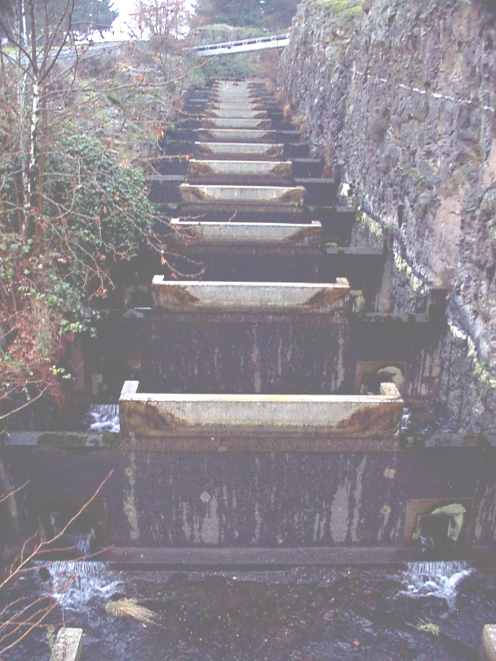
- Count station diffuser grating – Due for replacement. No evidence of lamprey trapping during dewaterings. Option; install design change along wall.
- Entrance weir guides – same as above.
John Day South
- Grating – Same as above. Prioritization for ¾” grating; 1) South ladder upper diffuser 2) South ladder dewater exposed grating 3) North ladder dewater exposed grating 4) South entrance and south collection channel grating 5) Remainder of collection channel 6) Remainder of north fishway.
- South entrance depression – Immediately upstream of SE1 weir. Approx 12’ depression. Option; round upper edge. Ramp not feasible due to grating and distance.
- Wall Diffuser – Chain link grating. No longer used. Should be plated over. Picture below.
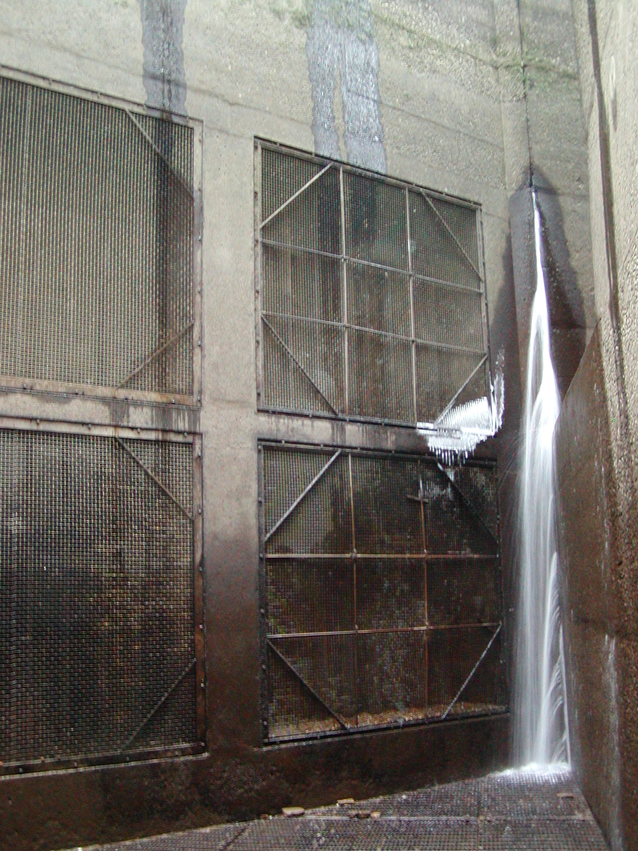
- Upper diffuser grating – 1” gap. Known lamprey trapping area. Change to ¾ same as north.
- New exit flow control weirs hydraulic sills – Option; design change. 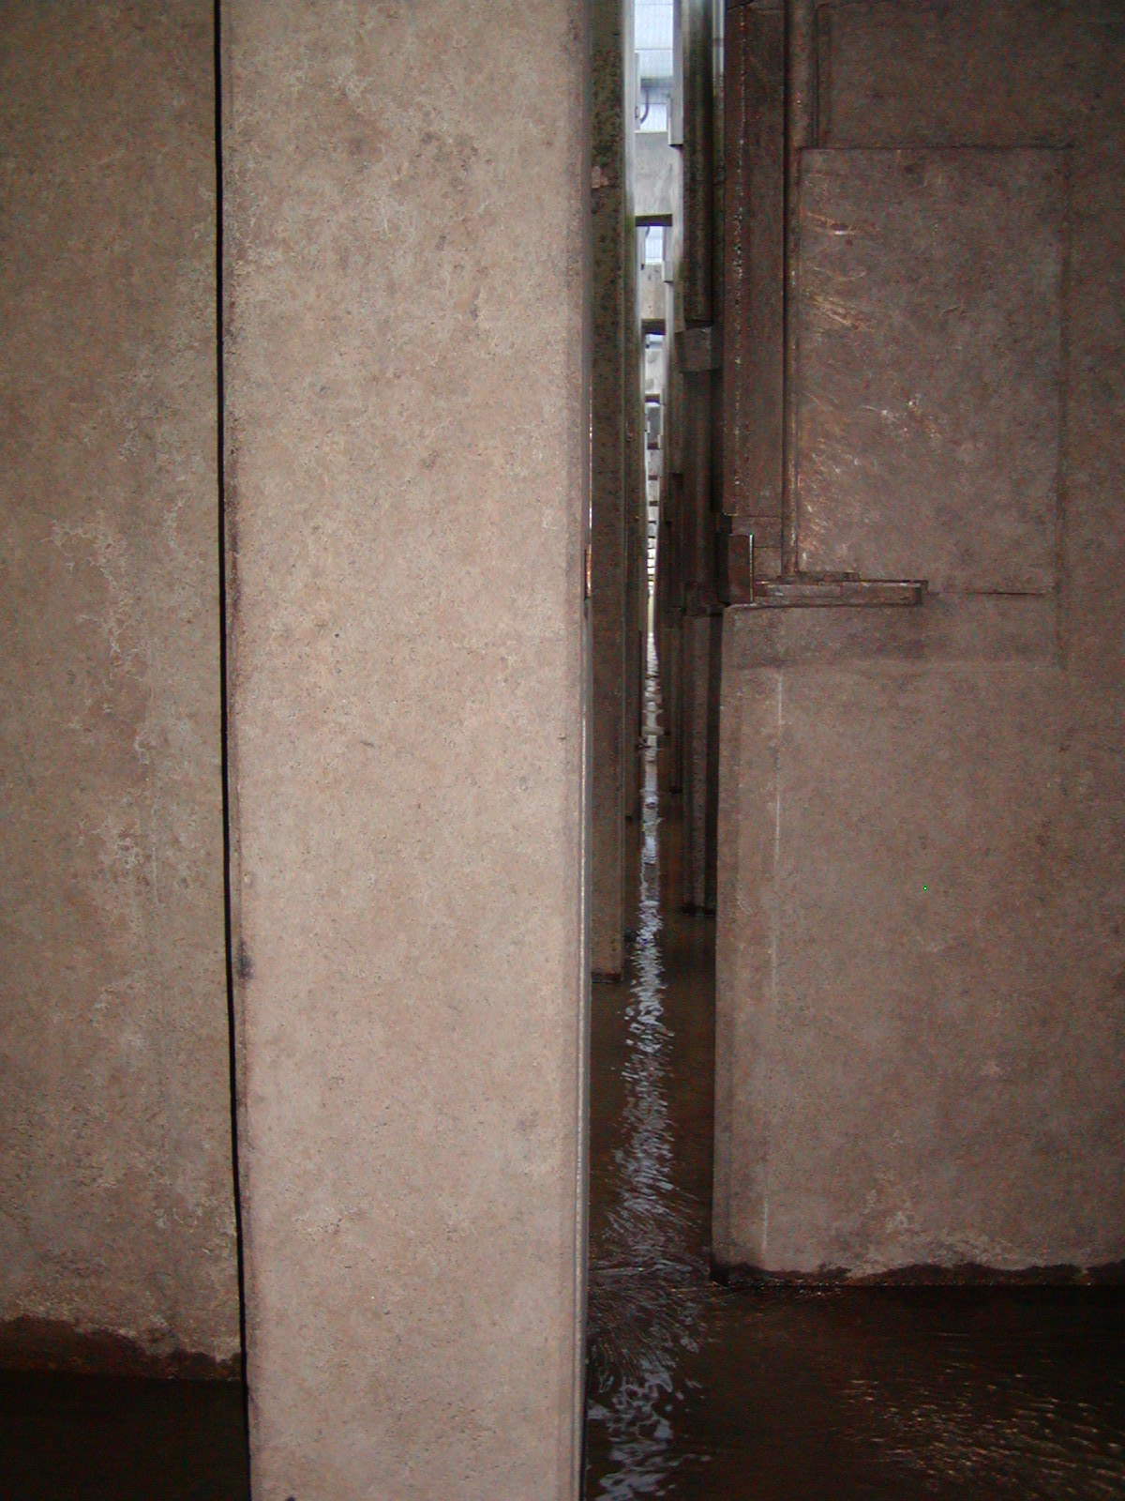
- Exit stub wall – 6” raise in floor under road deck located at half duplex antennae. Option; ramp. Picture below.
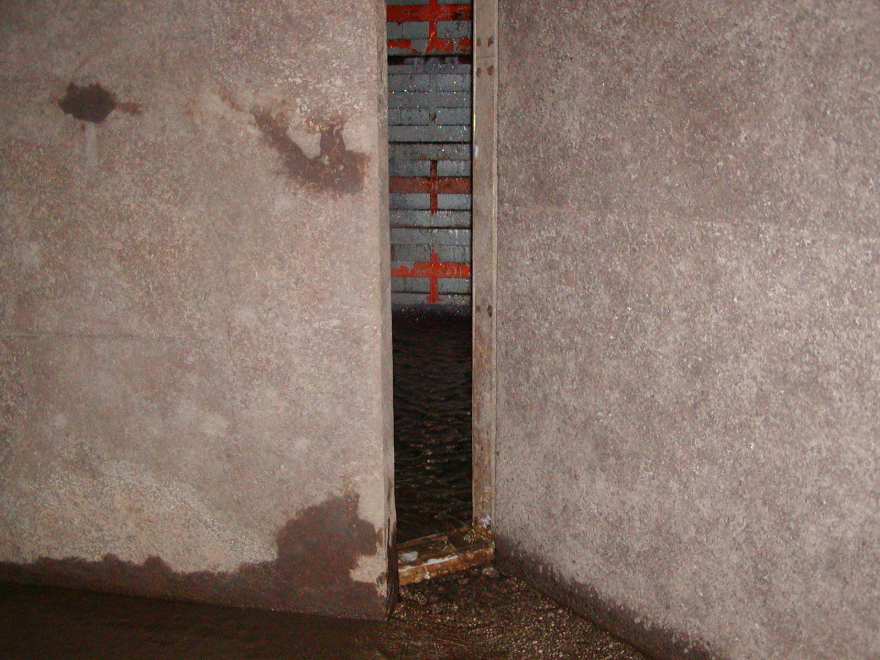
- Entrance weir guides – same as above.

John Day North
- Grating - same as above.
- Upper diffuser grating – Changed to ¾’. Seemed to be effective preventing entrapment. Floor raise approx 1’ still exists at first upstream weir. Grating for the south upper diffuser is comparable to the north and will be replace with ¾”.
- Exit hydraulic sills – Option; design change. Picture shows sills open. Normal operate with sills closed.
- Exit stub wall – same as above. Picture below.
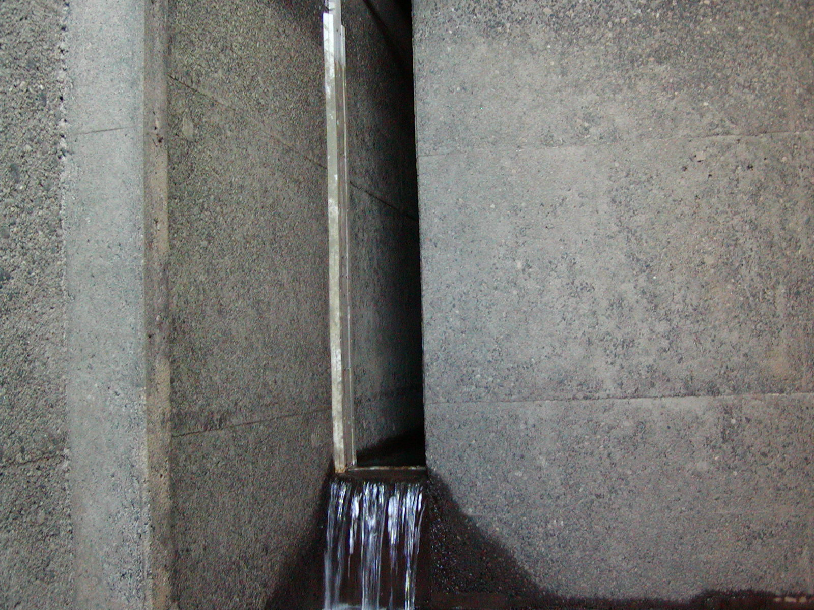
5) Orifice raised upstream of count station – Option; chamfer orifice floor. Picture below.
